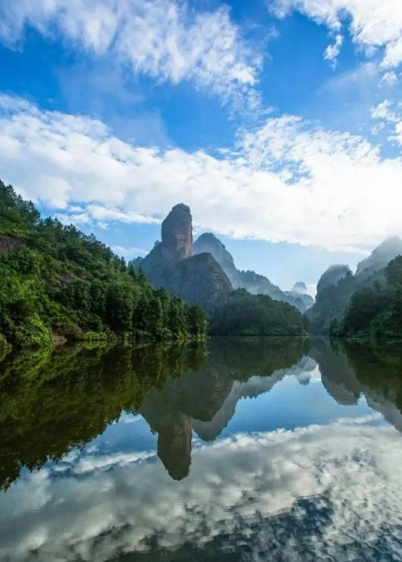

**Cuiwei Peak Tour**

This one-day climbing tour will take you on fascinating paths and stairs from the bottom to the top of Cuiwei Peak, which is recognized as the interest of 4A. During the process of reaching your destination, you'll have enough time to explore and be amazed by the extremely picturesque scenery. Especially amazing is the spectacular precipice unique to the natural world. Admire the terrific sight, listen to the beautiful voices of finchel, enjoy the local food made in the special mountain caves, talk with tourists from all over the world, and have a good night in your hotel which is booked in advance.

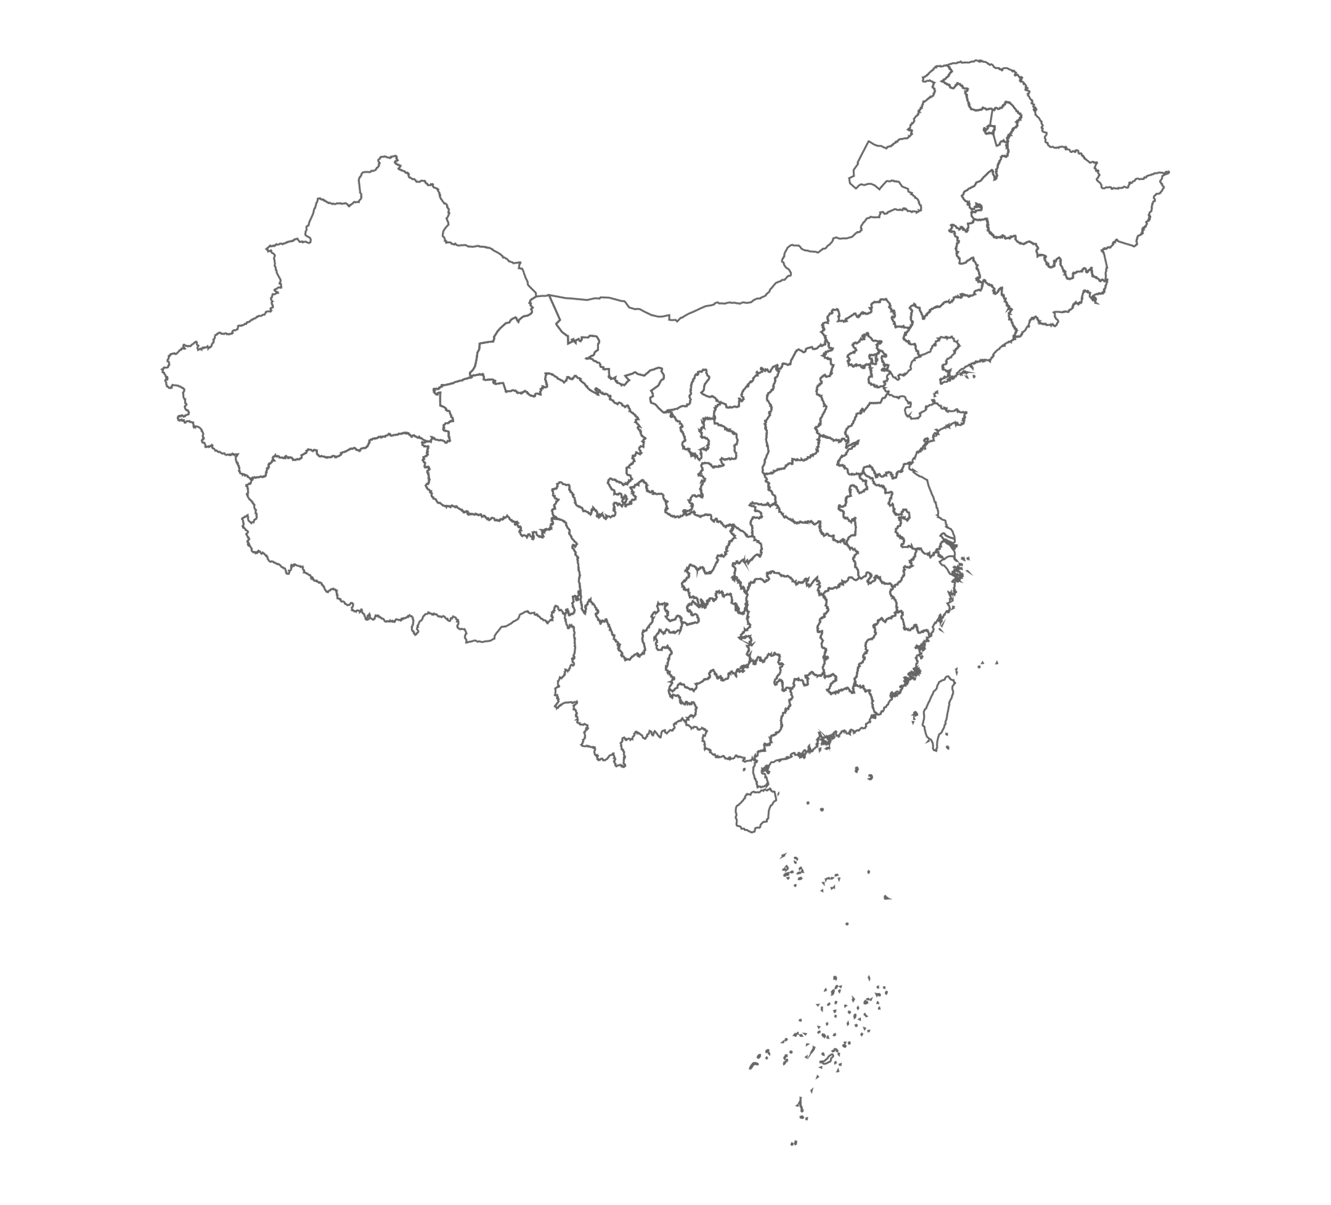

**The Forbidden City Tour**



Spending a whole day working in the forbidden city is quite a fantastic opportunity to explore the history of ancient China. With the fascinating, artistic and magnificent groups of palaces, you are capable of seeing the huge imagination of the emperors. Walk through the gate and you will find there is an official apartment, which was used to deal with the large country’s most important things. The number of stairs is about 100, showing the big power of emperors. If you go straight, you will find the palaces they lived in also pretty. The architecture enables you to stay and admire it in amazement. All in all, the Forbidden City is really a good place worth visiting.

**The West Lake Tour**

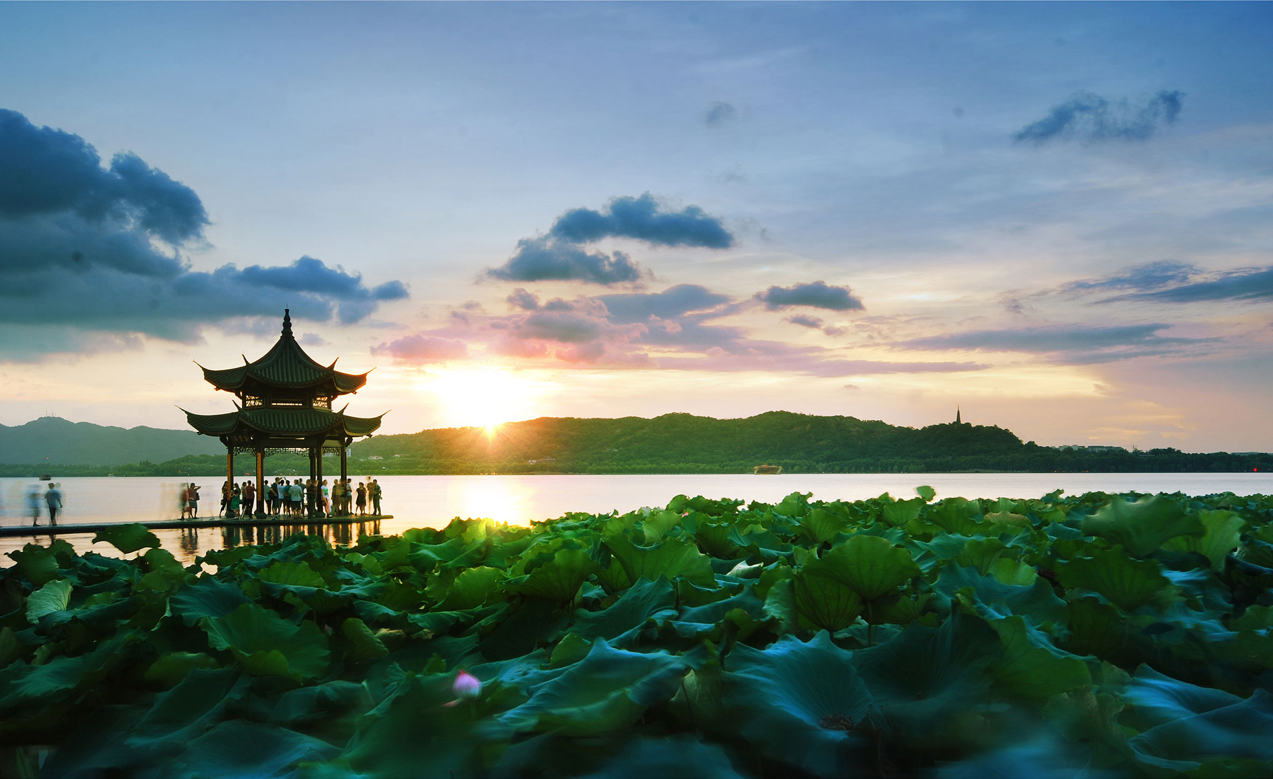

Enjoy the appealing sight as you spend a day going through the West Lake by Sudi which is made by Shi Su who is a famous poet in ancient China. What’s more, especially amazing is the sightseeing of the West Lake, which can made you lost in its beauty. Today, the West Lake attracts thousands of visitors who come to admire great wonders created by people and nature working together. It’s generally recognized that the West Lake is the best place to enjoy.

**Poyang Lake Tour**

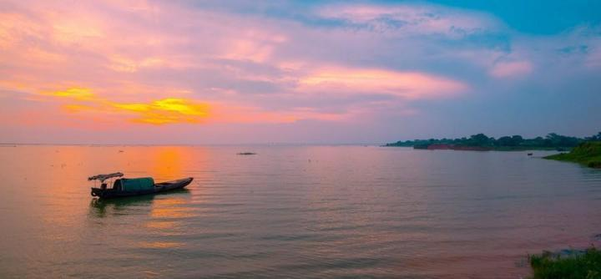

Poyang lake is one of the biggest lakes in China. Admiring the lake is wonderful, and visiting the grassland near Poyang lake is also an extremely wise choice. I have never seen such fascinating grass before. The grass there is very long and you may feel standing in the grass is like swimming in the sea. It sounds wonderful, but nobody can be beautiful forever. That's why I recommend that you should come here in summer but not in winter, or you will feel disappointed.